Coffee Rater App — Product Design Ideas
Oct 16, 2026 · @William

Vision and positioning
The app answers two questions Google Maps can't: how good is the coffee here, drink by drink, and can I sit and work here? Every rating is tied to the drink someone actually ordered, and every cafe is scored on four separate metrics instead of one blended star.
Who it's for
- Coffee drinkers who want the best flat white or long black nearby, not just a popular cafe.
- Students and remote workers who need wifi, power and a table they won't be moved on from.
- Brunch and social goers who care about food and atmosphere as much as the cup.
How it differs
 | Google Maps | CafeRadar | This app
Rating | One star score | One star score plus vibe tags | Four scores: Coffee, Food, Vibe, Work
Coffee detail | Free-text reviews only | Specialty badge | Score per drink type, beans, price
Work suitability | None | Vibe tags, busy times | A dedicated Work score with wifi, power and laptop-policy tags
Data source | Google users | Appears to reuse Google ratings | Its own community ratings
The one-line pitch: find the best cup and the right seat, rated by people who drank it.

Lessons from CafeRadar
CafeRadar gets the map-first feel right, but its scores look borrowed from Google and its navigation repeats itself. Borrow the patterns, not the look.
What CafeRadar does | Keep, change or drop | Our version
Rating badge on each map pin, clusters with counts | Keep | Pin shows the score for whichever metric is filtered
Category chips across the top (Brunch, Roasters, Bakery) | Change | Chips are the four metrics, so filtering matches how people rate
"How does this place feel?" tags (Quiet, Lively, Cozy) | Keep | Vibe tags collected in the review, not just shown
Busy-times chart | Keep, later | Could we pull these from google maps?
"Is this your cafe?" claim card, owner onboarding path | Drop | No owner features in initial version
4.5 (624) rating, likely Google's count | Change | Show our own score; show Google's only as a greyed fallback
Sign-up screen before browsing | Keep | Keep sign up screen
Home, Search and Explore as separate tabs | Drop | Search lives on the map; one less tab
Floating List button collides with the bottom sheet | Fix | One draggable sheet that is the list
Black and gold theme | Avoid | A distinct identity (see Visual identity)

Rating model
Coffee is the only required rating; Food, Vibe and Work each have a "Didn't try" option. Forcing all four would push people to invent scores for food they never ordered.
Metric | What it measures | Prompt in the review | Optional quick tags
Coffee | The drink you had | "How was your flat white?" | Strong, smooth, bitter, too hot, great milk
Food | Anything you ate | "How was the food?" | Brunch, pastries, vegan options, good value
Vibe | Atmosphere and service | "How did it feel?" | Quiet, lively, cozy, bright, friendly staff, slow service
Work | Fit for working or study | "Could you work here?" | Wifi, power outlets, laptop-friendly, no laptops at lunch, big tables
Every metric is rated from 1 to 5 stars in half-star steps, so 3.5 or 4.5 is possible.
How scores are shown
- Each metric shows its own average and its own count, such as "Work 4.2 (18)". A Coffee score from 40 people and a Work score from 3 shouldn't look equally certain.
- Rank with a weighted average that pulls low-count cafes toward the city average. One 5-star review shouldn't top the map.
- Weight recent reviews more, since cafes change baristas, beans and owners.
- Hide a metric's score until it has 3 ratings, and show "New" instead.
Coffee by drink type
The Coffee score is also split by drink, which is the app's signature detail: "Flat white 4.7 (23) · Long black 4.1 (9)". Suggested drink list, Australian names first:
- Espresso-based: espresso, ristretto, long black, americano, piccolo, macchiato, cortado, magic, flat white, latte, cappuccino, mocha.
- Brewed: batch brew, pour over, cold brew.
- Iced: iced latte, iced long black, espresso tonic.
- Other (Phase 2): chai, matcha, hot chocolate. These are scored but kept out of the Coffee average.
- Milk (optional chip): full cream, skim, oat, soy, almond, lactose-free. Oat versus dairy can change a rating a lot.

Home: map and filters
The app opens on a map centred on you, with four metric chips across the top. Choosing a chip changes what every pin shows, so the map answers one question at a time.
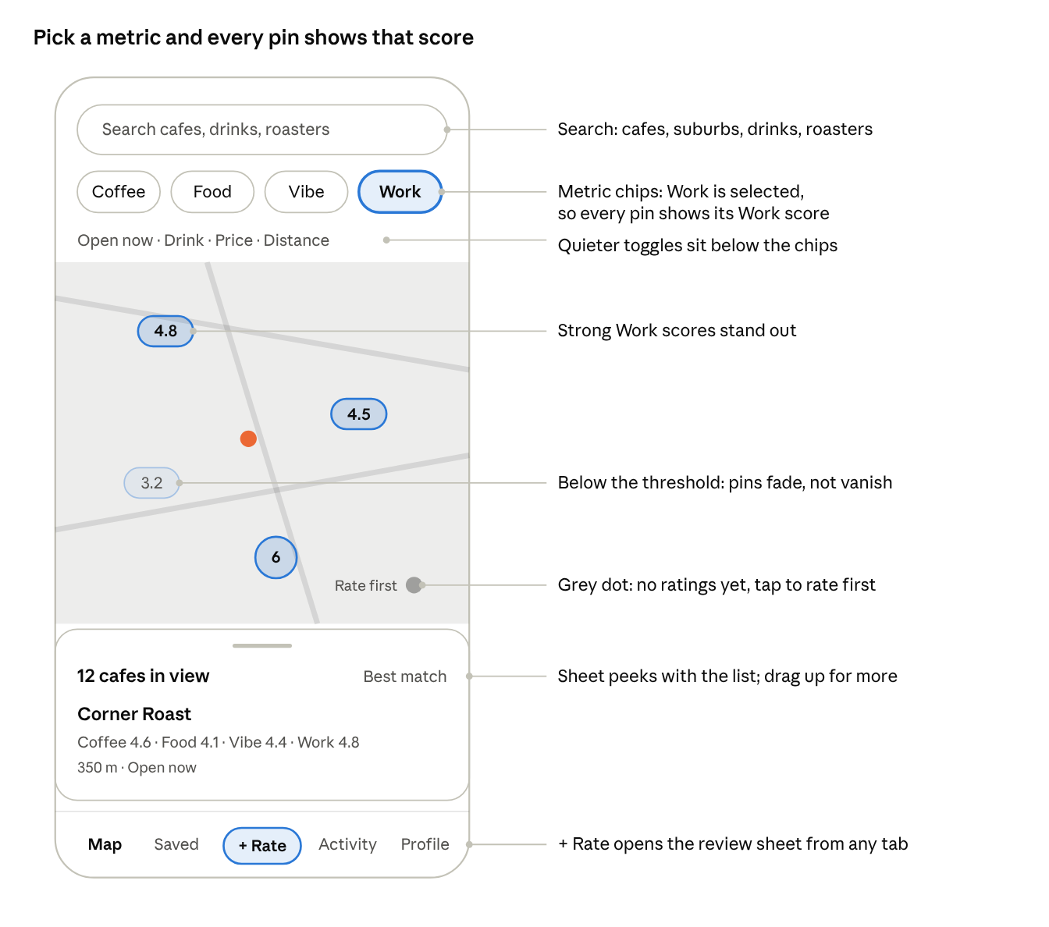
map home wireframe · Work filter on
With Work selected, pins switch to Work scores, weak cafes fade and unrated cafes invite a first review.
The "lens" idea
- With no chip selected, pins show the Coffee score, the app's core metric.
- Tap Work and every pin re-labels to its Work score with a laptop icon. Cafes below the threshold fade out rather than vanish, so people keep their bearings.
- Tapping a selected chip opens a small sheet: minimum stars (Any, 3+, 4+, 4.5+) and that metric's tags, such as Wifi or Power outlets for Work.
- Several chips can combine, such as Coffee 4+ and Work 4+. The pin then shows the lower of the two.
Pins
- Colour by score band, with one hue per metric, so a glance shows where the good cafes cluster.
- Cafes from Google with no community ratings appear as small grey dots labelled "Rate first". That turns gaps into an invitation.
- Clusters show a count and the best score inside them.
Below the chips
- A second row of quieter toggles: Open now, Drink ("Best flat white"), Price, Distance.
- The search bar sits above the chips and searches cafes, suburbs, drinks and roasters.
Bottom sheet
- Peeks with "12 cafes in view" and a sort control (Best match, Nearest, Most rated).
- Drag up for the full list; each row shows the four scores as small icons with numbers.
- One sheet replaces CafeRadar's separate List button.

Cafe page
The cafe page leads with the four scores and what to order, then the detail for people who want it. A sticky "Rate this cafe" button sits at the bottom, beside Directions and Save.
Top to bottom:
- Header: community photos (most recent first), name, suburb, distance, open now.
- Score row: four tiles, Coffee, Food, Vibe and Work, each with its stars and count. Tapping a tile filters the reviews below to that metric.
- What to order: the top-rated drinks, such as "Magic 4.8 (14)" and "Flat white 4.6 (31)". Drinks with too few ratings are listed without a score.
- Beans and price:
  - "Beans: Market Lane seasonal blend, reported by 6 people", with a "Still right?" confirm button.
  - "Flat white about $5.50, from 9 reports". Shown as a median so one odd entry doesn't skew it.
- Working here: Work score, top tags (Wifi, Outlets), laptop policy, and a busy-hours chart once there's enough check-in data.
- Vibe: the most common tags, shown as chips with counts.
- Reviews: filter by drink or metric; sort by recent or helpful. Each card shows the drink, its Coffee rating, other ratings as small icons, the comment, and an optional photo and price.
Google's official Places API doesn't provide popular-times data. Busy hours would therefore need to come from the app's own check-ins.

Review flow
A review should take under 30 seconds while the cup is still on the table. It runs in one bottom sheet that steps forward, with the required parts first and the extras folded away.
- Which cafe? Pre-filled with the nearest cafe if location is on; one tap to change. Also reachable from the cafe page or a "+ Rate" button in the tab bar.
- What did you have? A grid of drink chips, with the cafe's most-rated and your usual drinks first. Optional milk chip. "+ Another drink" adds a second drink to the same visit.
- Rate it. Large tap-friendly stars for each metric, in half steps (tap the left half of a star, or drag):
  - Coffee is required.
  - Food, Vibe and Work each start on "Didn't try" and fill in when tapped.
  - After a star tap, that metric's quick tags appear underneath.
- Say a few words. A short comment, required, roughly 10 to 280 characters. The placeholder adapts to the drink: "How was the flat white? Strength, milk, temperature…"
- Add details (optional, collapsed):
  - Price: a stepper in AUD, pre-filled with the cafe's median for that drink.
  - Beans: autocomplete from known roasters, suggesting what others reported here.
  - Photo: camera or gallery, one photo to start.
- Post. A confirmation shows how the review moved the cafe's scores, then offers one follow-up, such as "Add work details?" if Work was skipped.
Trust rules
- One review per cafe per day per person; later visits add a new review rather than overwrite.
- A "Verified visit" badge when the review is posted within about 100 m of the cafe.
- Drafts save automatically if the app closes mid-review.

Additional feature ideas
The strongest extras build on the per-drink data, since no competitor I found has it. Phase numbers match the roadmap below.
Feature | What it does | Why it matters | Phase
Drink leaderboards | "Best magic in Fitzroy", "Best long black in the CBD" | Unique to per-drink ratings; very shareable | 2
Work mode | One toggle: open 2+ more hours, wifi, outlets, Work 4+ | Turns the Work score into an instant answer for students | 2
Coffee passport | Your map of visits, cups this month, favourite drink, money spent | Gives reviewers a personal reason to keep logging | 2
Lists | Save and share lists such as "Study spots" or "Weekend brunch" | Brings new users in through shared links | 2
Roaster pages | Which cafes serve a roaster's beans, on a map | Uses the bean data; a hook for roaster partnerships | 3
Price index | Cheapest flat white rated 4+ nearby | Uses the price data; good for students | 3
Taste match | "92% match" based on your past ratings | Personal ranking once someone has rated 10+ drinks | 3
Friends and reviewer badges | Follow people; badges like "Flat white regular" after 20 ratings | Social proof and a reason to review more | 3
Cafe owner tools | Claim a cafe, reply to reviews, update beans, hours and laptop policy | Better, owner-verified data | 3
"Are you at…?" prompt | Notification when you've been at a cafe for 10 minutes | More reviews, written in the moment | 3
Reviewer profiles | Tap a reviewer's name to see their profile and recent reviews | Lets people follow the taste of reviewers they trust | 2
Reviewer profiles: open design questions. Phase 1 shows a reviewer's name as plain text, and the Profile tab covers only your own account. Before building profiles for other people, settle these:
- Privacy. Do people expect their review history to be visible to strangers? Adding it means updating the privacy policy text.
- Safety. A profile page must offer the block and report actions, or it becomes a new place to harass someone. Blocked users must stay hidden.
- Content. What a profile shows: probably display name, member-since date, review count and recent reviews.
- Fit. It is a social feature, and Phase 1 leaves out leaderboards and similar. Build it once there is a real community to browse.

Visual identity and navigation
Give each metric its own colour and icon and use them everywhere: chips, pins, score tiles and review cards. People then learn the system once and read it at a glance.
Metric | Icon | Colour direction
Coffee | Cup | Espresso brown
Food | Fork and knife | Sage green
Vibe | Sparkle | Terracotta
Work | Laptop | Slate blue
Look and feel
- A warm light theme as the default, cream background with espresso text, and a dark mode. This stands apart from CafeRadar's black and gold.
- One characterful serif for headings and cafe names, paired with a clean sans for everything else.
- Photos from the community carry the colour; the interface stays quiet.
Tab bar (four tabs plus one action)
Map · Saved · + Rate · Profile
- Map holds search, so there's no separate Search or Explore tab.
- + Rate is the centre button and opens the review sheet.
Name: "Coffee Rater" is the placeholder. Candidates to test, not yet checked for trademarks or App Store availability:
Name | Why it works
Cupping | The industry's word for tasting and scoring coffee
Crema | The golden layer on an espresso; short and warm
Shot Notes | Tasting notes per shot; hints at per-drink reviews
Pourscore | Pour plus score; says what the app does
Four Cups | Echoes the four metrics
Cup & Desk | Coffee and working, in three words
Magic Hour | Nods to Melbourne's "magic" coffee
Flat White Club | Very Australian, with a community feel
Grounds | Coffee grounds, and "grounds for a visit"
Tamp | A barista action; short and easy to brand
Laptop Latte | Playful, and leads with the Work angle

Phase 1 screen designs
These are the chosen Phase 1 screens, 390 × 844 each. They are clickable on the design canvas, and the options we rejected stay there too.

Core screens
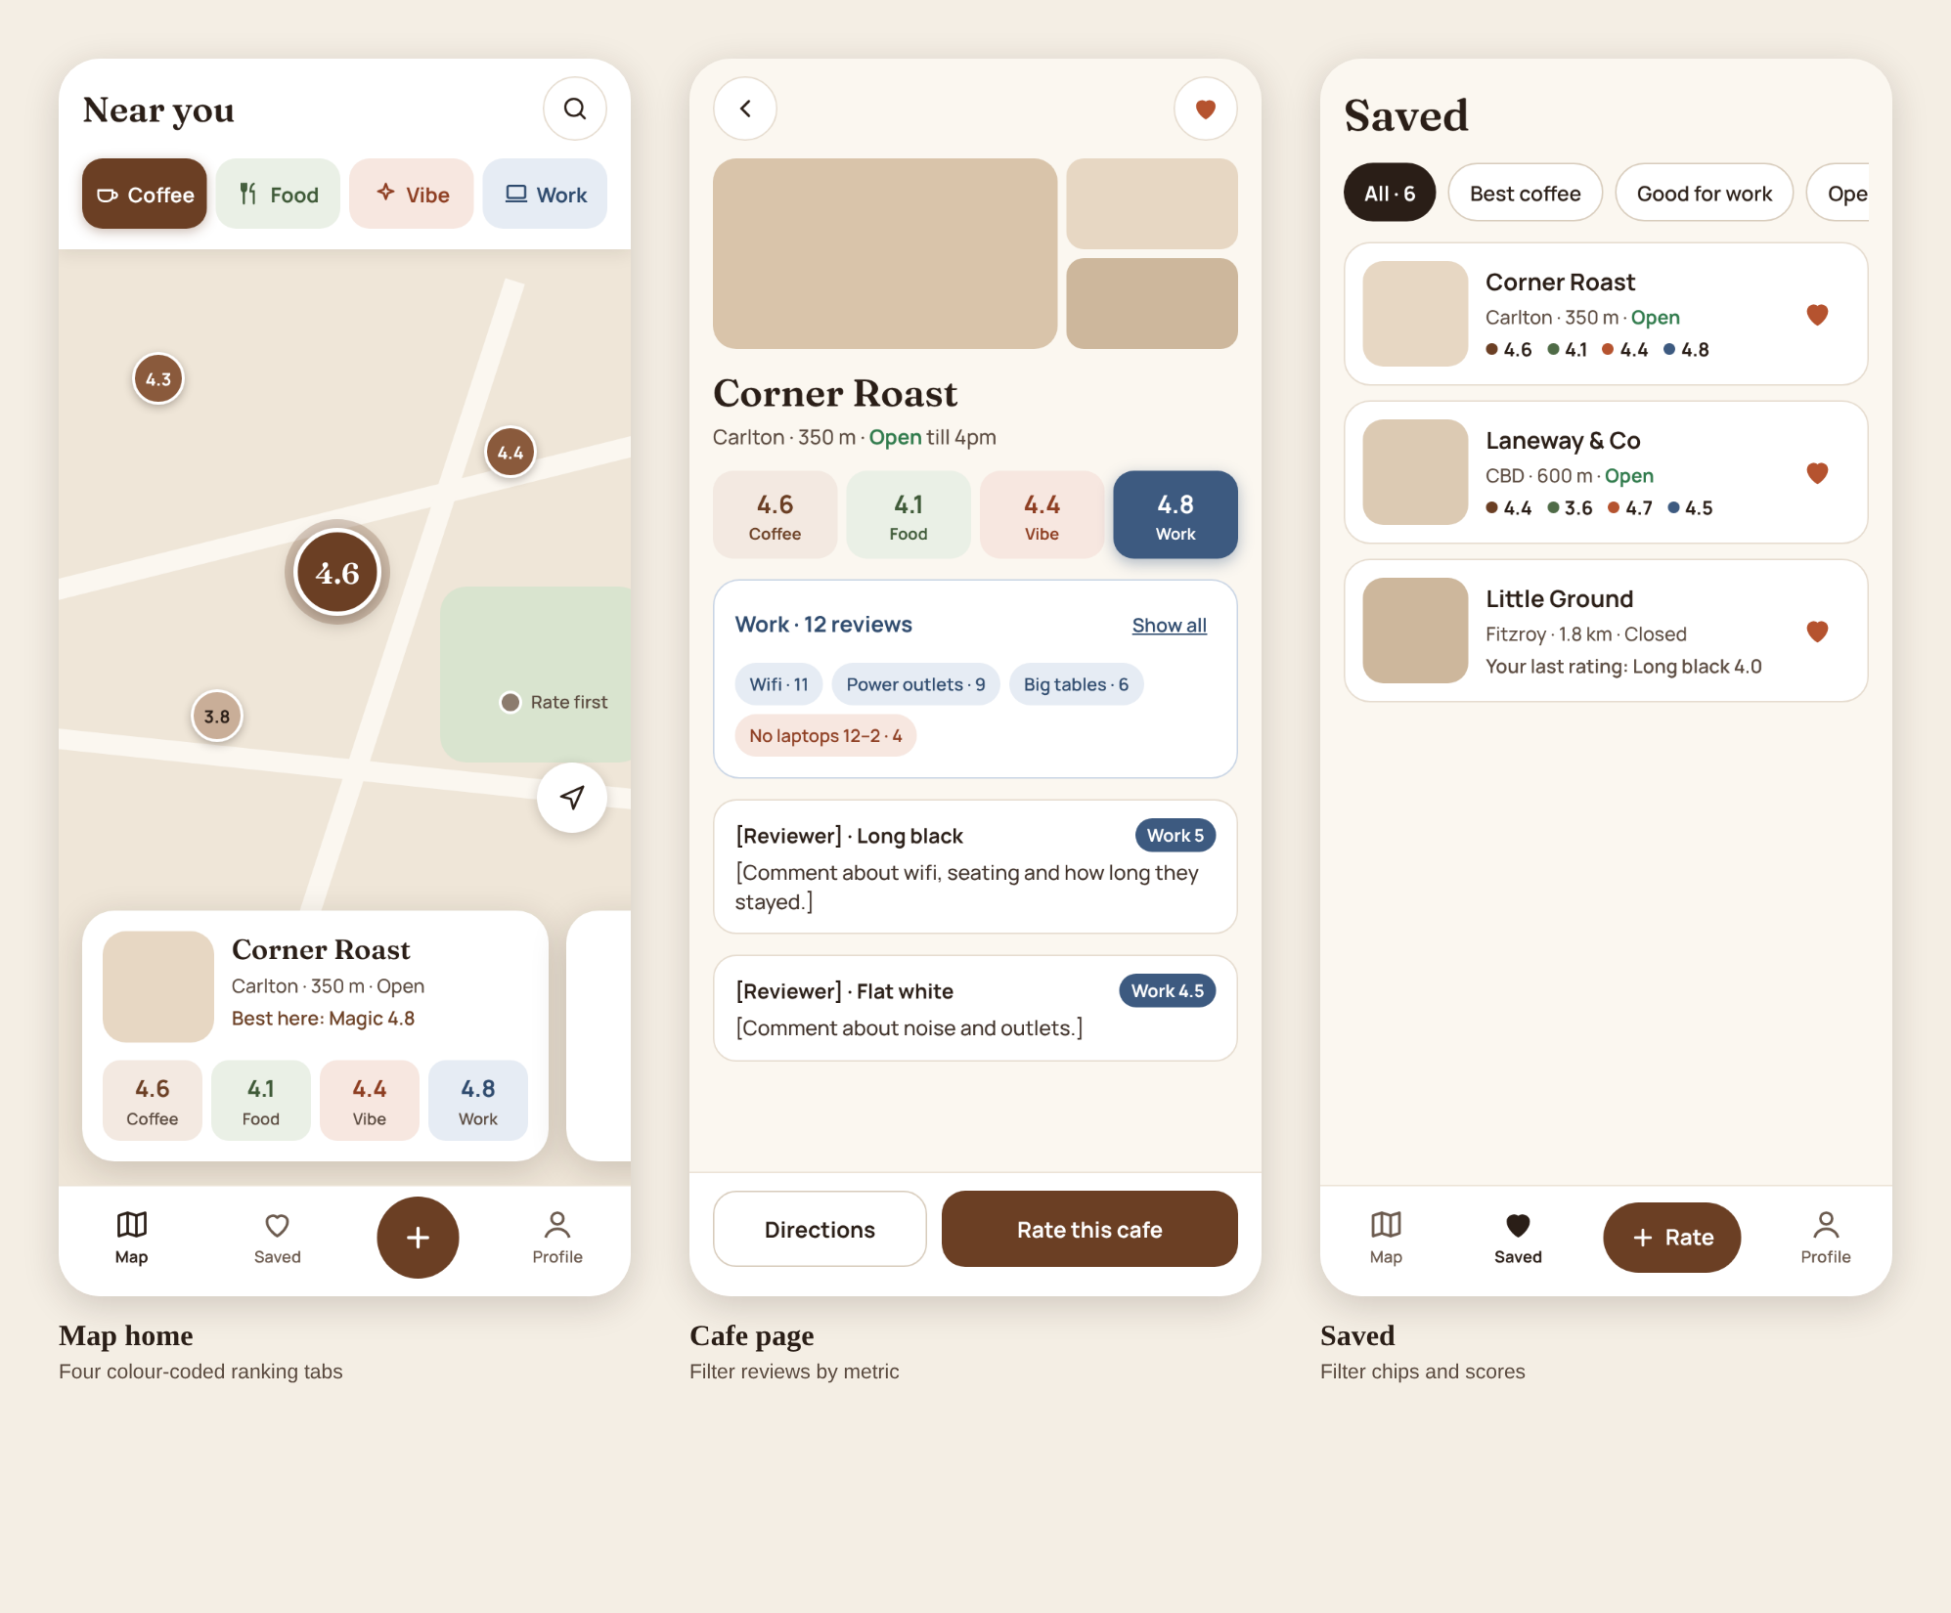
- Map home: four colour-coded ranking tabs (Coffee, Food, Vibe, Work) choose which score the pins show. The swipeable card at the bottom shows all four scores.
- Cafe page: four colour-coded metric tabs filter the reviews to one metric, and the footer has Directions and Rate this cafe.
- Saved: a list of saved cafes, each row showing all four scores. Updated 20 Oct 2026: the filter chips were dropped, so the Saved screen image still shows the previous design.
- Profile: your name and email (Edit changes the name), counts of reviews, cafes and saved cafes, then Activity (My reviews, Saved cafes), Settings (Location, Appearance, Account and password, Help and feedback) and Sign out. Updated 20 Oct 2026: the Profile image still shows a Notifications row, which was dropped because nothing sends notifications in Phase 1, and an Appearance row (System, Light, Dark) was added.
- My reviews: the person's own reviews, newest first. Each card shows the cafe, suburb and age, all four ratings (a dash where one was skipped), the drinks, the comment, the photo, and the price and beans. Chips sort or filter by Newest, Highest rated, By cafe and Has photo. The three-dot menu edits or deletes the review.
- Edit review: Edit review in the three-dot menu reopens the review wizard with the review's values filled in. It skips the cafe, drink and details steps, because the cafe, drinks, price, beans and photo can't be changed. Each drink's rating, Food, Vibe and Work, the tags and the comment can be changed, with no time limit, and the last button says Save changes. Scores recompute, and the review shows an “Edited” label on the cafe page and in My reviews. Added 20 Oct 2026.

Profile and My reviews
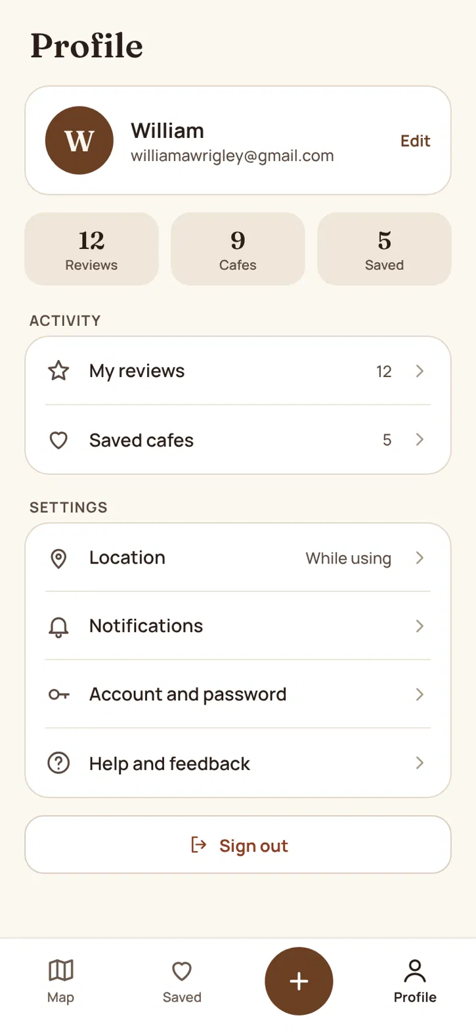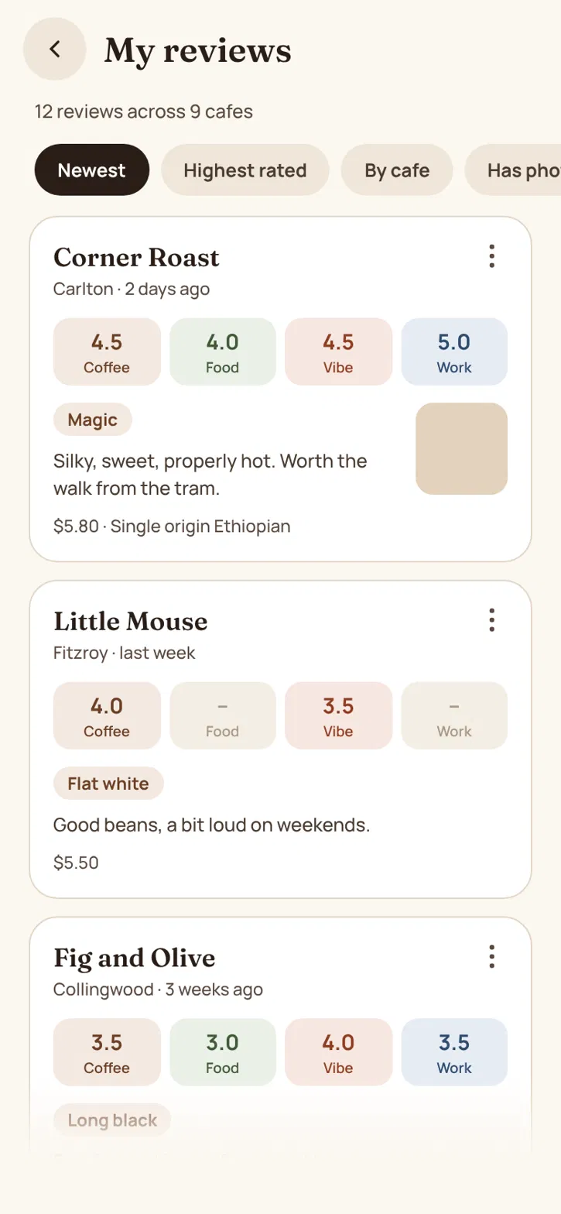
Profile (left) and My reviews (right), 390 wide each.

Onboarding
Four screens, shown once. The pitch comes first, sign-up second and location permission last, so the map opens with pins around the user.
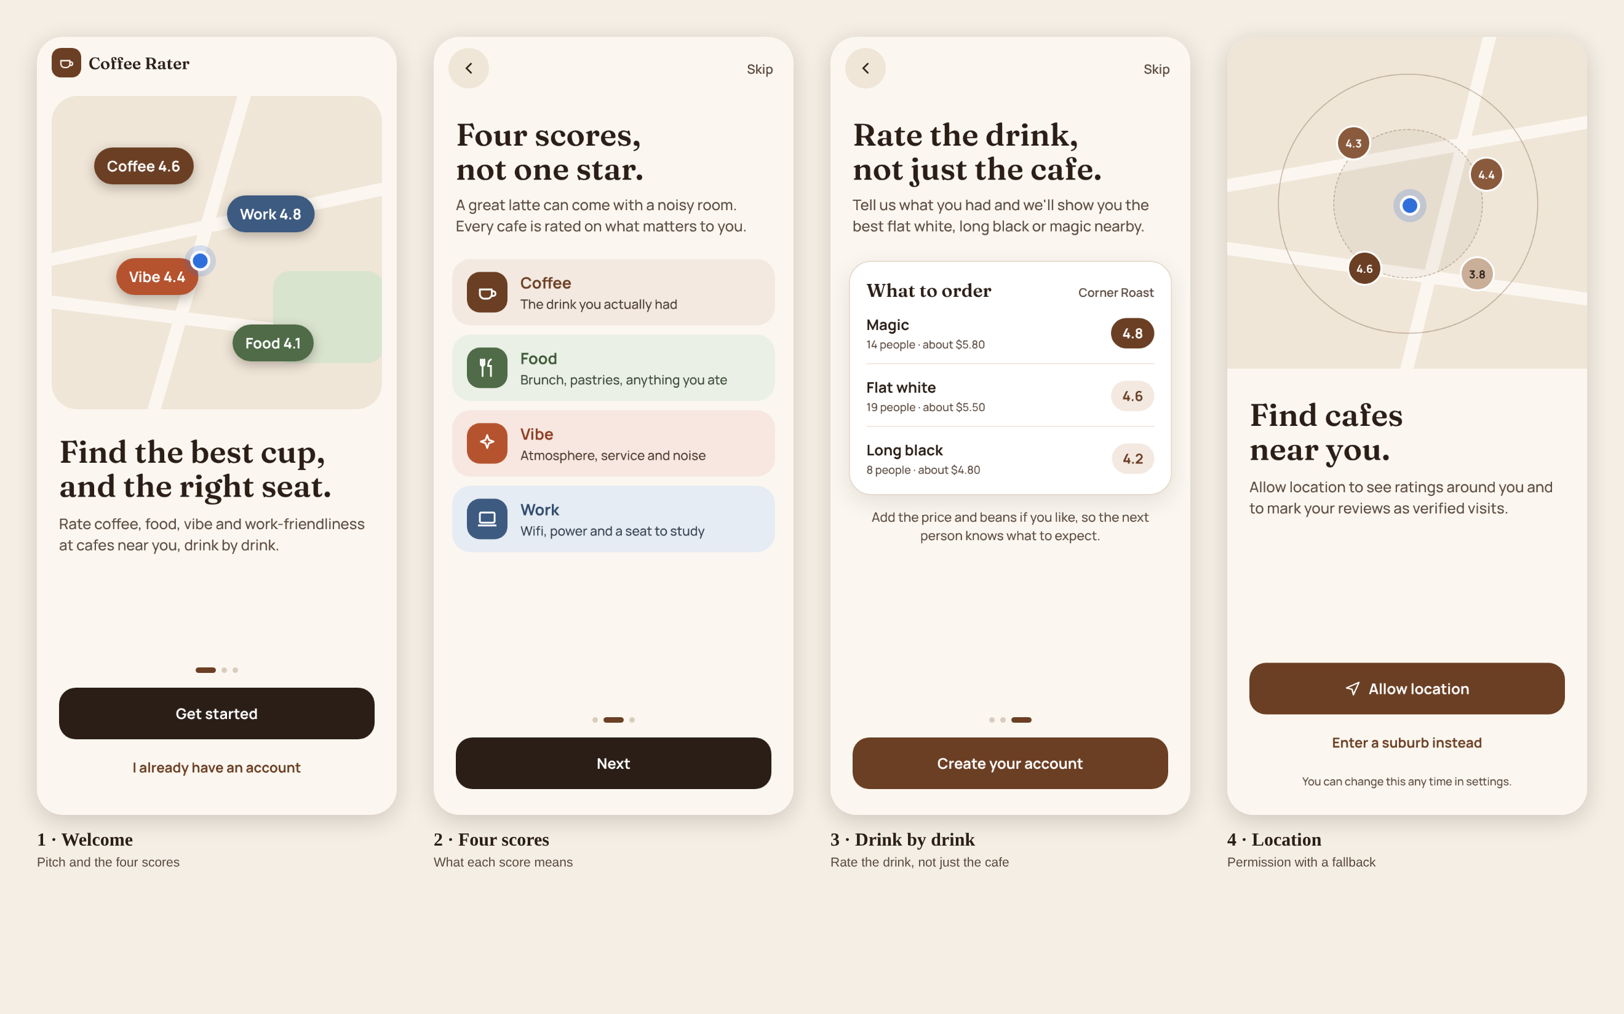
- Welcome: the pitch, with the four scores shown as pins on a map.
- Four scores: one line on what Coffee, Food, Vibe and Work each mean.
- Drink by drink: a sample "what to order" card that shows why we ask which drink people had.
- Location: Allow location, or Not now (the map then opens on Melbourne CBD). Reviews from users who allow location get the verified visit badge. Updated 18 Oct 2026: the earlier “Enter a suburb instead” fallback was dropped, so the Location screen image still shows the previous design.
Skip on screens 2 and 3 goes to Create account, never past it.

Sign in and create account
Sign-up stays before the map (decision kept). The earlier "Not now" guest link is removed from both screens.
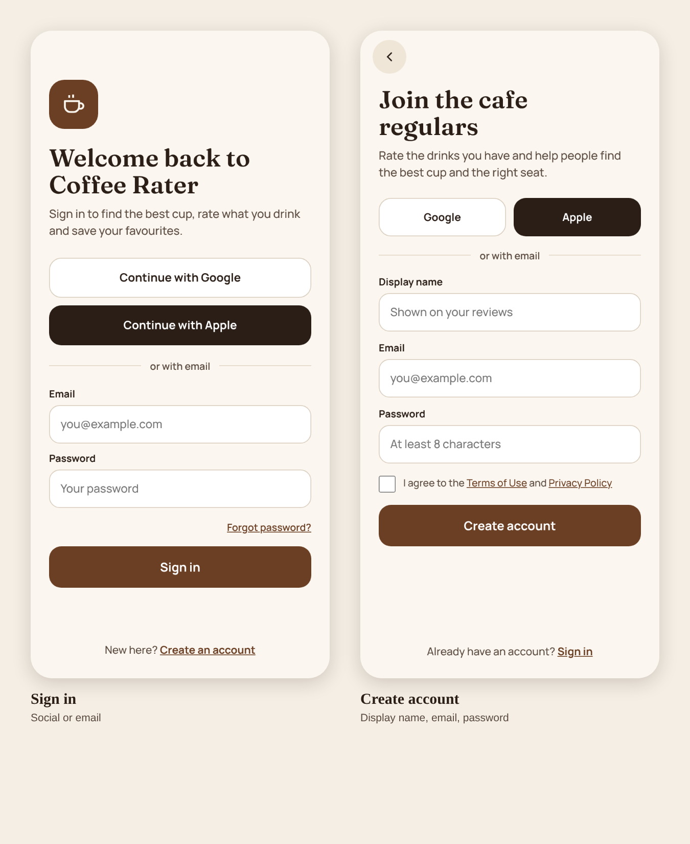

Review wizard
Six steps plus a confirmation. Only the Coffee rating is required; Food, Vibe and Work offer Didn't try.
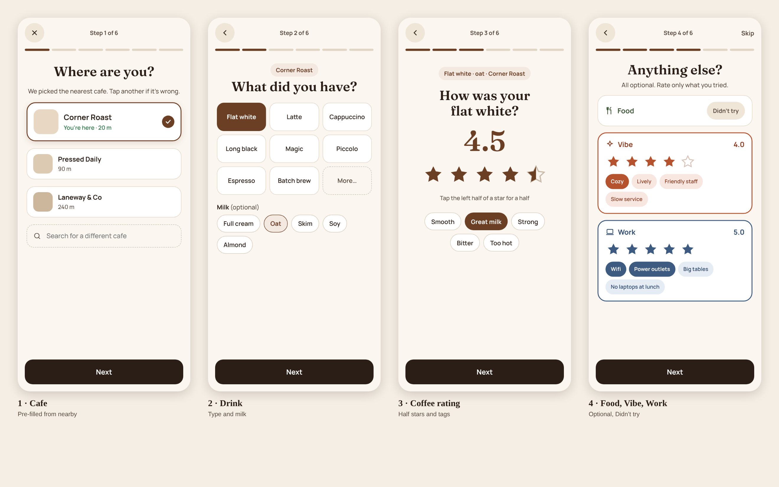
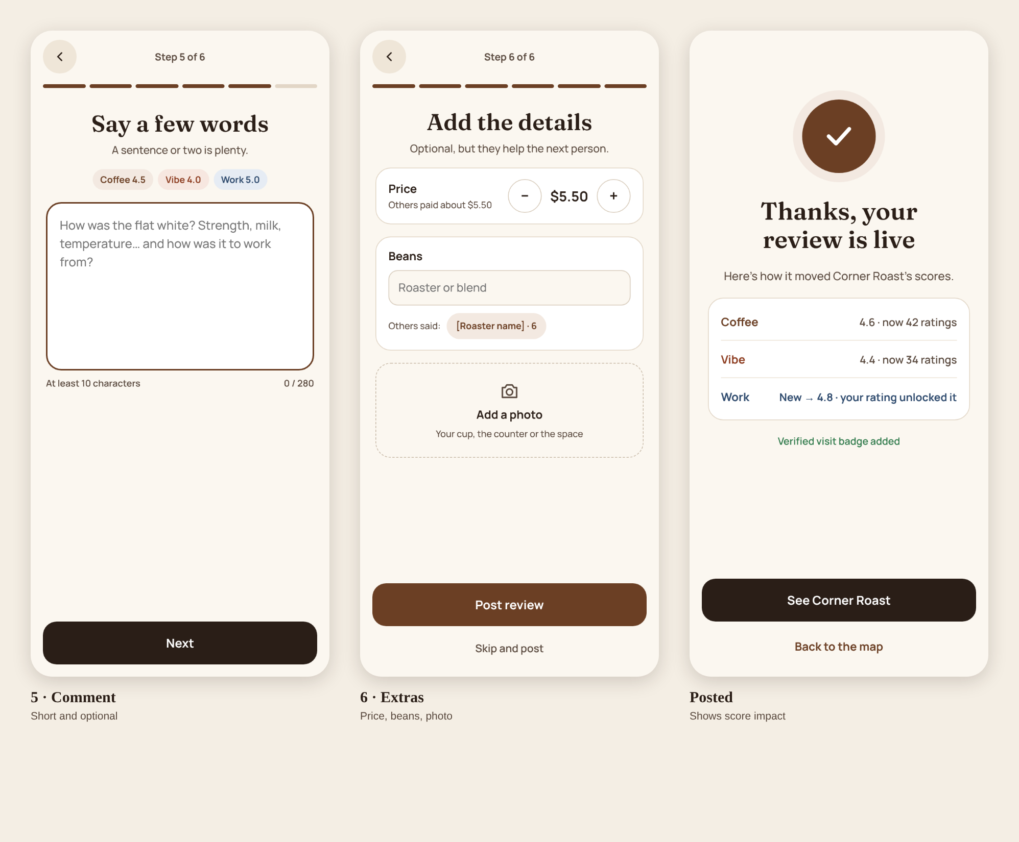

Open gaps
- No minimum-star filter: the tabs choose which score the pins show, but nothing yet hides cafes below, say, 4.0. The original brief asked for filters on the four metrics.
- Sign-up before browsing: this may cost installs, since people see nothing before creating an account. We kept it; worth testing.

Launch strategy and roadmap
The biggest risk is an empty map, not a missing feature. Most competitors I found have tens of users, which suggests this is where they stall.
Beating the cold start
- Launch small: Melbourne CBD, Carlton and Fitzroy first. A dense map in three suburbs beats a sparse one across Australia.
- Borrow a baseline: show Google's rating greyed out until a cafe has 3 community ratings, so the map is never blank.
- Seed reviewers: recruit 30 to 50 people from uni coffee clubs and study groups, who fill the Work metric fast.
- Make gaps rewarding: "First to rate" badges and grey "Rate first" pins.
- Counter cards: a QR card at a few friendly cafes, "Rate your coffee", linking straight into the review flow.
Google Maps Platform notes
- Use Google Places for cafe names, locations and hours; store only place IDs long-term, plus your own review data.
- Places calls are billed per request, so cache place IDs and load details only when a cafe is opened.
- Show Google attribution wherever Google data appears.
Roadmap
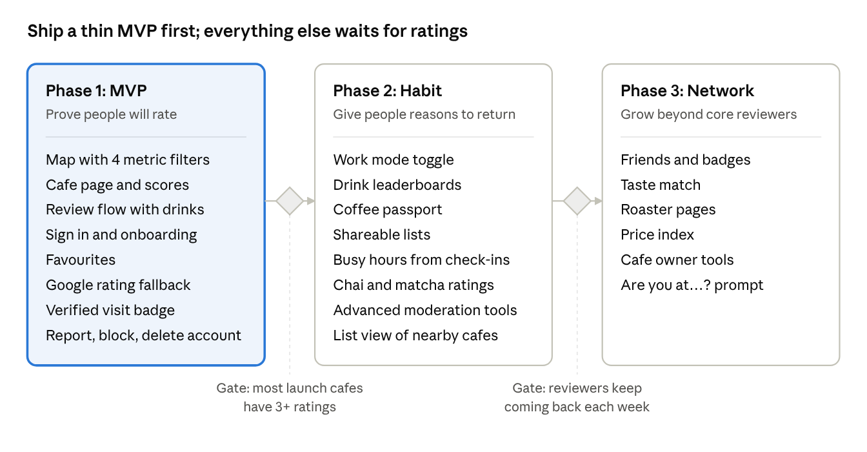
roadmap · 3 phases, 2 gates
Phase 1 stays deliberately thin; each later phase starts only once the gate before it is met.

What Coffee Rater would need beyond the SDD
Both stores have rules for apps with user-generated content. The minimum is:
- A “Report review” action on each review.
- A way to remove reported content. Even a simple admin view in Supabase Studio counts as a process.
- Blocking abusive users. Apple asks for this explicitly.
- Published contact details, plus terms that forbid objectionable content.
On top of that comes the account deletion flow, which also has to delete or anonymise that user’s reviews and photos. It’s maybe a week of extra work. It’s also a good portfolio feature, because it shows you understand trust and compliance.

Decisions
Question | Decision
Required metrics | Coffee required; Food, Vibe and Work optional
Star scale | Half stars allowed, 1 to 5
Google rating | Shown greyed out as a fallback until a cafe has 3 community ratings
Chai and matcha | Added in Phase 2, kept out of the Coffee average
Platform | Out of scope; this doc covers design only
Revenue | Not a focus until there's a real community
Moderation | Minimum in Phase 1: report review, removal, blocking users, account deletion (see the compliance section above). Advanced tools deferred to Phase 2
App name | "Coffee Rater" as placeholder; candidates under Visual identity
Sign-up | Required before browsing; no guest mode. Onboarding runs once, then the map
Minimum-star filter | Open: the tabs choose which score pins show, but there is no cutoff such as 4.0 and up yet
List view | Dropped from Phase 1; moved to the Phase 2 roadmap. Tab bar is Map, Saved, Rate, Profile

